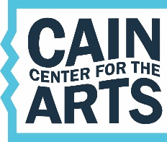 Executive Director’s Report

Board of Directors Meeting 3.11.19

**Architectural/Construction**

* + The town board unanimously approved the Architectural and PreConstruction contracts at their March 4th meeting. We are now putting together the project schedule.
* **Finance**
  + Nothing major to report
* **Marketing** **& PR**
  + Our new website design launched last month.
  + We had a great turnout for the Old Town Arts District Soiree. We received great press from it.
* **Outreach** 
  + I presented at the N. Mecklenburg Women’s Club in February at both the evening meeting and the lunch meeting. Overall about 125 women attended.
  + The N Mecklenburg Rotary Club is naming us as the beneficiary of this year’s Golf Tournament. The tournament will be held May 6 at Northstone Country Club – it starts at 10am and will go all day. **Please put this on your calendars and consider putting together a foursome to play.** They will also be looking for hole sponsors. This is a GREAT opportunity to bring friends, neighbors, and business associates who need to learn more about our project. All money generated from the event will go to our educational outreach programs for 2019-2020.
* **Campaign** 
  + We have begun major planning for our big spring event, which we are naming the Founders’ Ball. We will be reviewing information for this at the March meeting with more detailed description coming in April.
* **Staff**
  + Our PR Taskforce has identified the two firms to interview for the PR Consultancy. Interviews will be happening next week.