Sponsorship Proposal for
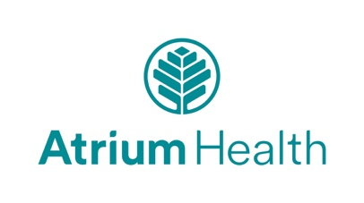
Official Health Care Partner of Cain Center for the Arts

Sponsorship duration – 3 seasons
July 1, 2023, through June 30, 2026, with option to extend
Sponsorship value
$60,000 per season x 3 seasons = $180,000

Sponsorship benefits
MARKETING & PROMOTION
- Exterior and interior on-site branding/logo placement, including banners, marquee, and lobby monitors
- Prominent placement of Atrium information kiosk in Cain Center lobby (Atrium to provide)
- Prominent brand/logo placement in printed materials & media
- Recognition in targeted eblast promotions and social media posts
- Recognition at annual Season Preview Party for Cain Center donors and sponsors
- Opportunities to speak from the stage at XX events each season (TBD and subject to artists approval)
- Messages displayed on lobby monitors at XX events each season (number of events TBD)
- One pre-or post-concert reception per season TBD.

CAIN CENTER EVENTS
- Four season tickets to Ingersol Rand Performing Arts Series per season.
- Donor Lounge access for Cain Center events

FACILITY ACCESS
- One standard rental of any room, excluding theater, within the Cain Center per season.

COMMUNITY ENGAGEMENT
- One Health Fair event at the Cain Center per season
- Opportunity for Atrium team members to volunteer for Cain Center events and programs

Additional options
- Exclusive health care sponsorship + $10,000 per season
- Pre- or post-event reception for Atrium execs or clients at a Cain Center concert, date TBD – at cost

