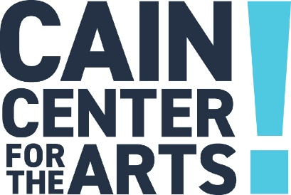

Executive Committee Meeting
September 21 , 2023

- Welcome

- Approval of August 17, 2023 Executive Committee Meeting Minutes

- Development Report

- Programs Report

- Operations Report

- Financial Report

  - Renewal of lines of credit with UCB

- Executive Report

- Other Business

- Adjourn

The next Executive Committee Meeting is October 19.

