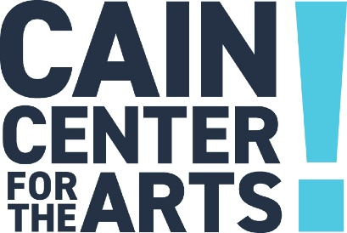

Executive Committee Meeting
December 14, 2023

- Welcome

- Approval of November 16, 2023 Executive Committee Meeting Minutes

- Development Report

- Programs Report

  - Added Performances

- Operations Report

- Financial Report

  - FY25 Budget Draft

- Executive Report

- Other/New Business

  - Rental Program Launch
    - Policy Revisions

- Adjourn

The next Executive Committee Meeting is January 18, 2023.

