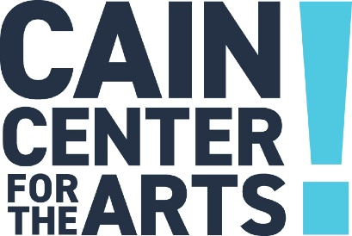

Board Meeting Agenda
December 19, 2023

- Welcome

- Approval of November 21, 2023 Board Meeting Minutes

- Development Report

- Programs Report

  - Added Performances

- Operations Report

- Financial Report

  - FY25 Budget Draft

- Executive Report

- Other/New Business

  - Rental Program Launch
    - Policy Revisions

- Adjourn

The next Board Meeting is January 23, 2024.

