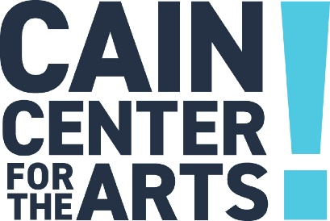

Executive Committee Meeting
January 18, 2024

- Welcome

- Approval of December 14, 2023, Executive Committee Meeting Minutes

- Development Report

- Programs Report

- Operations Report

- Financial Report

- Executive Report

- 2023 Strategic Plan Executive Committee Working Session

- Adjourn

The next Executive Committee Meeting is February 22, 2024.

