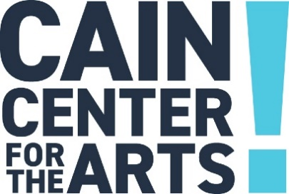

Executive Committee Meeting
February 22, 2024

- Welcome

- Approval of January 18, 2024, Executive Committee Meeting Minutes

- Development Report

  - Arts & Business Breakfast
  - Directors Choice

- Programs Report

- Operations Report

  - Evacuation and Emergency Response Update

- Financial Report

  - ACTION – Amendment to Accounting Policies and Procedures

- Executive Report

- New Business:

  - Construction Committee Update
  - Strategic Plan Update
  - Nominating Committee Update

- Adjourn

The next Executive Committee Meeting is March 21, 2024.

